（b）not cfl

assume w= 1^m 0 1^m 1^m 0 1^m

Let w=uvxyz with |vxy|<=m |vy|>=1

block a b c d e f

1111111111 0 1111111111 111111111 0 111111111

m 1 1 0 m 1

case 1 :vxy in block a|c|d|f , pump down, uxz= 1^(m-j)01^m 1^m01^m,not uu ,so not in L

case 2 : vxy in block ab|bc|de|ef, pump down, uxz =1^(m-j)1^m 1^m01^m ,not uu, so not in L

case 3:vxy in block abc|def, pump down, uxz=1^(m-j)1^(m-i) 1^m01^m ,not uu, so not in L

case :4 vxy in block cd ,pump down,uxz=1^m01^(m-i) 1^(m-j)01^m, not uu,so not in L

So the language is not cfl

(c) not cfl

assume w=a^(m+2) b^(m+1) c^m

let w=uvxyz with |vxy|<=m |vy|>=1

blcok a b c

aaaaaa bbbbb ccccccc

case 1: in single block

when vxy is in a

pump down ,a^m+2-j b^m+1 c^m, cause j>=1, so m+2-j<=m+1,naw<=nbw,counter

when vxy is in b or c

pump up, a^m+2 b^m+1+j c^m or a^m+2 b^m+1 c^m+j

cause j>=1,m+1+j>=m+2 or m+j>= m+1,which means nbw>= naw or ncw>=nbw,counter,

case 2: in double block

in ab, pump down, a^m+2-j b^m+1-i c^m, cause i>=1, nbw<= ncw ,counter

in bc, pump up, a^m+2 b^m+1+i c^m+j, cause i>=1, nbw>= naw ,counter

case 3: in 3 block:impossible

so it is not cfl

(d)assume w= a^(m^2)

let w=uvxyz with |vxy|<=m |vy|>=1

pump up with i=1

a^(m^2+j)

m^2<m^2+j<=m^2+m<m^2+2m+1=（m+1）^2

so m^2+j is not perfect square

so it is not cfl

3. Adjust page proportions to see the TM, if it is still not clear enough, you can check the png files in a4 folder

(1)

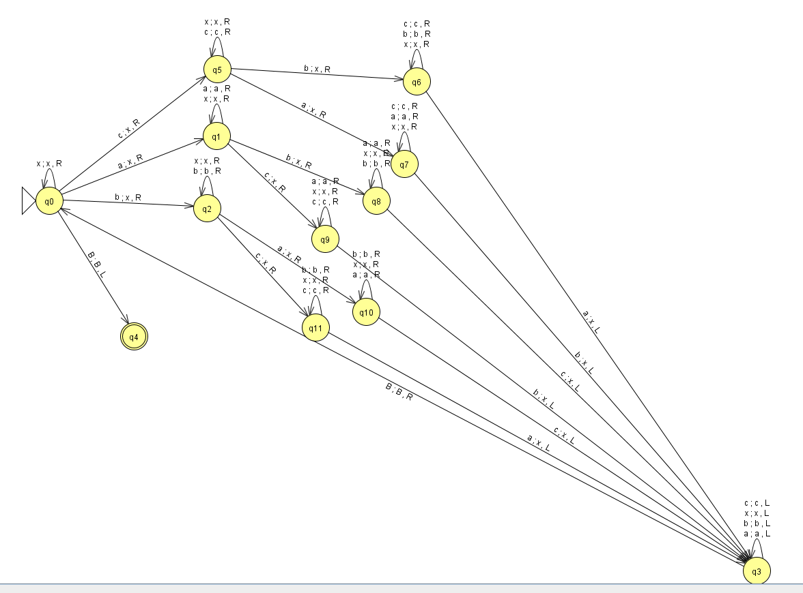

B means blank

(2)

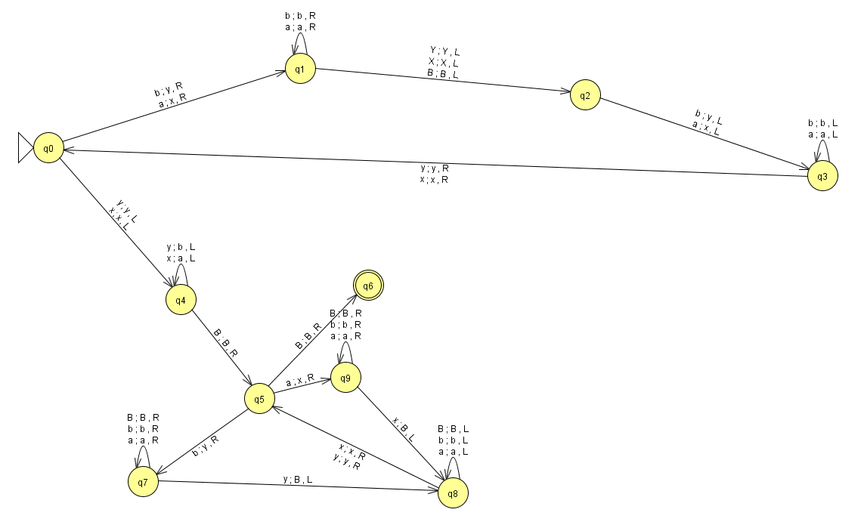

B means blank

(3)

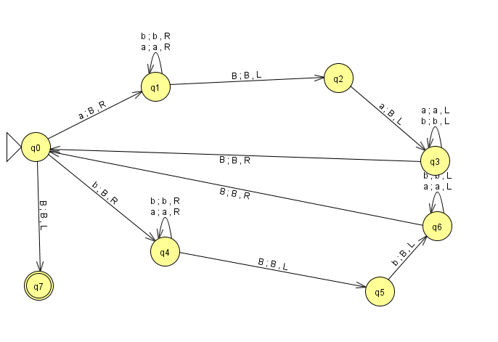

B means blank

4.

(1)

B111110111110...011111B

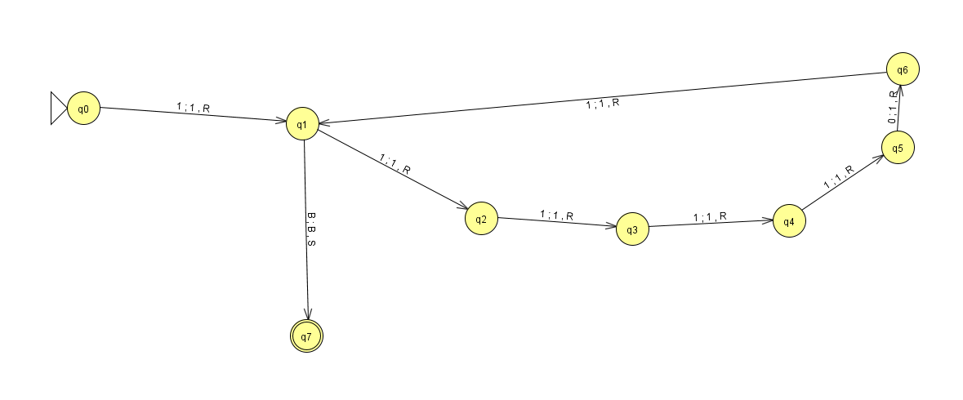

(b)